Stock Report

Brad Boehmke

2018-12-31

## AMZN Recommendation: BUY

Based on our internal trading algorithm, we believe that the **AMZN** stock will **increase** in price during the next trading period.

## Price History

The chart below is made with the quantmod R package, a widely used package for collecting and visualizing financial data in R. You can learn more about quantmod at the website <www.quantmod.com>.

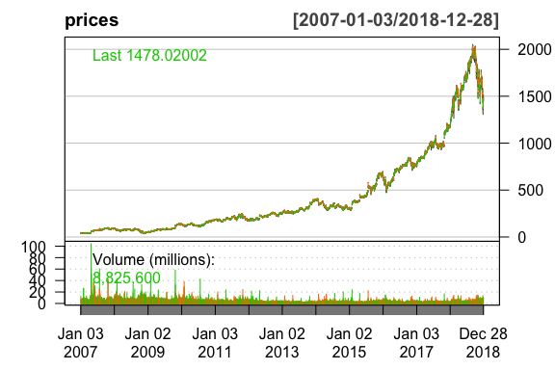

## Method

This forecast was predicted with the *recency algorithm*, a simple—probably useless—method for determining stock prices. The recency algorithm predicts that the next price movement, $M_{j}$, will be in the same direction as the most recent price movement. $M_{i}$.

$$M_{i}={Close}_{i}-{Open}_{i}$$

$$M_{j}=\left\{\begin{matrix}>0, & if M_{i}>0 \\ ≤0, & if M_{i}≤0\end{matrix}\right.$$

## Raw Data

The table below displays the most recent 10 days of price data for the AMZN stock.

Stock information for previous 10 business days

|  |  |  |  |  |  |  |
| --- | --- | --- | --- | --- | --- | --- |
|  | AMZN.Open | AMZN.High | AMZN.Low | AMZN.Close | AMZN.Volume | AMZN.Adjusted |
| 2018-12-14 | 1638.00 | 1642.57 | 1585.00 | 1591.91 | 6367200 | 1591.91 |
| 2018-12-17 | 1566.00 | 1576.13 | 1505.01 | 1520.91 | 8829800 | 1520.91 |
| 2018-12-18 | 1540.00 | 1567.55 | 1523.01 | 1551.48 | 6523000 | 1551.48 |
| 2018-12-19 | 1543.05 | 1584.53 | 1483.18 | 1495.08 | 8792200 | 1495.08 |
| 2018-12-20 | 1484.00 | 1509.50 | 1432.69 | 1460.83 | 9991800 | 1460.83 |
| 2018-12-21 | 1464.99 | 1480.00 | 1363.96 | 1377.45 | 13640300 | 1377.45 |
| 2018-12-24 | 1346.00 | 1396.03 | 1307.00 | 1343.96 | 7220000 | 1343.96 |
| 2018-12-26 | 1368.89 | 1473.16 | 1363.01 | 1470.90 | 10411800 | 1470.90 |
| 2018-12-27 | 1454.20 | 1469.00 | 1390.31 | 1461.64 | 9722000 | 1461.64 |
| 2018-12-28 | 1473.35 | 1513.47 | 1449.00 | 1478.02 | 8825600 | 1478.02 |